**Experiment 3.1**

**Student Name:** Sahil Kaundal **UID:** 21BCS8197

**Branch:** CSE (Lateral Entry)  **Section/Group:** 616/A

**Semester:** 6th **Date of Performance:** 07/05/2023

**Subject Name:** Mobile Application Development Lab **Subject Code:** 20CSP-356

1. **Aim:**

Implement building blocks for Android Application using different layouts (such as linear, relative and absolute).

1. **Objective:**

* Understanding of the interactions between user interface and underlying application infrastructure.
* Design an android application which uses different layouts in android studio.

1. **System Requirements:**

* Microsoft Windows 7/8/10 (32-bit or 64-bit)
* 4 GB RAM minimum, 8 GB RAM recommended (plus 1 GB for the Android Emulator)
* 2 GB of available disk space minimum, 4 GB recommended (500 MB for IDE plus 1.5 GB for Android SDK and emulator system image)
* 1280 x 800 minimum screen resolution
* Java JDK5 or later version
* Java Runtime Environment (JRE) 6 Android Studio

1. **Steps/Program:**

**activity_main.xml**

<?xml version="1.0" encoding="utf-8"?>

<androidx.constraintlayout.widget.ConstraintLayout xmlns:android="http://schemas.android.com/apk/res/android"

xmlns:app="http://schemas.android.com/apk/res-auto"

xmlns:tools="http://schemas.android.com/tools"

android:layout_width="match_parent"

android:layout_height="match_parent"

tools:context=".MainActivity">

<LinearLayout

android:id="@+id/linearLayout"

android:layout_width="295dp"

android:layout_height="240dp"

android:orientation="vertical"

app:layout_constraintBottom_toBottomOf="parent"

app:layout_constraintEnd_toEndOf="parent"

app:layout_constraintStart_toStartOf="parent"

app:layout_constraintTop_toTopOf="parent"

app:layout_constraintVertical_bias="0.977">

<TextView

android:id="@+id/textView4"

android:layout_width="wrap_content"

android:layout_height="wrap_content"

android:text="Sahil Kaundal"

android:textSize="25dp"

android:padding="15dp"

app:layout_constraintBottom_toTopOf="@+id/linearLayout"

app:layout_constraintEnd_toEndOf="parent"

app:layout_constraintStart_toStartOf="parent"

app:layout_constraintTop_toTopOf="parent"

app:layout_constraintVertical_bias="0.516" />

<TextView

android:id="@+id/textView5"

android:layout_width="wrap_content"

android:layout_height="wrap_content"

android:text="21BCS8197"

android:padding="15dp"

android:textSize="25dp"

app:layout_constraintBottom_toTopOf="@+id/linearLayout"

app:layout_constraintEnd_toEndOf="parent"

app:layout_constraintStart_toStartOf="parent"

app:layout_constraintTop_toTopOf="parent"

app:layout_constraintVertical_bias="0.516" />

<TextView

android:id="@+id/textView6"

android:layout_width="wrap_content"

android:layout_height="wrap_content"

android:text="Computer Engineering"

android:textSize="25dp"

android:padding="15dp"

app:layout_constraintBottom_toTopOf="@+id/linearLayout"

app:layout_constraintEnd_toEndOf="parent"

app:layout_constraintStart_toStartOf="parent"

app:layout_constraintTop_toTopOf="parent"

app:layout_constraintVertical_bias="0.516" />

</LinearLayout>

<TextView

android:id="@+id/textView2"

android:layout_width="wrap_content"

android:layout_height="wrap_content"

android:text="Hello Android User"

app:layout_constraintBottom_toTopOf="@+id/linearLayout"

app:layout_constraintEnd_toEndOf="parent"

app:layout_constraintHorizontal_bias="0.498"

app:layout_constraintStart_toStartOf="parent"

app:layout_constraintTop_toTopOf="parent"

app:layout_constraintVertical_bias="0.147" />

<LinearLayout

android:layout_width="302dp"

android:layout_height="268dp"

android:orientation="horizontal"

app:layout_constraintBottom_toTopOf="@+id/linearLayout"

app:layout_constraintEnd_toEndOf="parent"

app:layout_constraintStart_toStartOf="parent"

app:layout_constraintTop_toBottomOf="@+id/textView2">

<TextView

android:id="@+id/textView9"

android:layout_width="wrap_content"

android:layout_height="wrap_content"

android:padding="15dp"

android:text="content 1"

android:textSize="15dp"

app:layout_constraintBottom_toTopOf="@+id/linearLayout"

app:layout_constraintEnd_toEndOf="parent"

app:layout_constraintStart_toStartOf="parent"

app:layout_constraintTop_toTopOf="parent"

app:layout_constraintVertical_bias="0.516"

tools:ignore="TextSizeCheck" />

<TextView

android:id="@+id/textView8"

android:layout_width="wrap_content"

android:layout_height="wrap_content"

android:padding="15dp"

android:text="content 2"

android:textSize="15dp"

app:layout_constraintBottom_toTopOf="@+id/linearLayout"

app:layout_constraintEnd_toEndOf="parent"

app:layout_constraintStart_toStartOf="parent"

app:layout_constraintTop_toTopOf="parent"

app:layout_constraintVertical_bias="0.516"

tools:ignore="TextSizeCheck" />

<TextView

android:id="@+id/textView7"

android:layout_width="wrap_content"

android:layout_height="wrap_content"

android:padding="15dp"

android:text="content 3"

android:textSize="15dp"

app:layout_constraintBottom_toTopOf="@+id/linearLayout"

app:layout_constraintEnd_toEndOf="parent"

app:layout_constraintStart_toStartOf="parent"

app:layout_constraintTop_toTopOf="parent"

app:layout_constraintVertical_bias="0.516"

tools:ignore="TextSizeCheck" />

</LinearLayout>

<Button

android:id="@+id/button6"

android:layout_width="wrap_content"

android:layout_height="wrap_content"

android:text="Button"

app:layout_constraintBottom_toTopOf="@+id/textView2"

app:layout_constraintEnd_toEndOf="parent"

app:layout_constraintStart_toStartOf="parent"

app:layout_constraintTop_toTopOf="parent" />

</androidx.constraintlayout.widget.ConstraintLayout>

**activity_main2.xml**

<?xml version="1.0" encoding="utf-8"?>

<androidx.constraintlayout.widget.ConstraintLayout xmlns:android="http://schemas.android.com/apk/res/android"

xmlns:app="http://schemas.android.com/apk/res-auto"

xmlns:tools="http://schemas.android.com/tools"

android:layout_width="match_parent"

android:layout_height="match_parent"

tools:context=".MainActivity2">

<RelativeLayout

android:layout_width="fill_parent"

android:layout_height="fill_parent"

xmlns:android="http://schemas.android.com/apk/res/android"

tools:ignore="MissingConstraints">

<Button

android:id="@+id/button1"

android:layout_width="wrap_content"

android:layout_height="wrap_content"

android:text="Top Left Button"

android:layout_alignParentLeft="true"

android:layout_alignParentTop="true"/>

<Button

android:id="@+id/button2"

android:layout_width="wrap_content"

android:layout_height="wrap_content"

android:text="Top Right Button"

android:layout_alignParentTop="true"

android:layout_alignParentRight="true"/>

<Button

android:id="@+id/button3"

android:layout_width="wrap_content"

android:layout_height="wrap_content"

android:text="Bottom Left Button"

android:layout_alignParentLeft="true"

android:layout_alignParentBottom="true"/>

<Button

android:id="@+id/button4"

android:layout_width="wrap_content"

android:layout_height="wrap_content"

android:text="Bottom Right Button"

android:layout_alignParentRight="true"

android:layout_alignParentBottom="true"/>

<Button

android:id="@+id/button5"

android:layout_width="fill_parent"

android:layout_height="wrap_content"

android:text="Middle Button"

android:layout_centerVertical="true"

android:layout_centerHorizontal="true"/>

</RelativeLayout>

</androidx.constraintlayout.widget.ConstraintLayout>

**MainAcitivity.java**

package com.example.exp8;

import android.content.Intent;

import android.view.View;

import android.widget.Button;

import androidx.appcompat.app.AppCompatActivity;

import android.os.Bundle;

public class MainActivity extends AppCompatActivity {

Button b1 ;

@Override

protected void onCreate(Bundle savedInstanceState) {

super.onCreate(savedInstanceState);

setContentView(R.layout.activity_main);

b1 = findViewById(R.id.button6);

b1.setOnClickListener(

new View.OnClickListener() {

@Override

public void onClick(View v) {

Intent i = new Intent(MainActivity.this,MainActivity2.class);

startActivity(i);

}

}

);

}

}

**MainAcitivity2.java**

package com.example.exp8;

import android.content.Intent;

import android.view.View;

import android.widget.Button;

import androidx.appcompat.app.AppCompatActivity;

import android.os.Bundle;

public class MainActivity2 extends AppCompatActivity {

Button b2 ;

@Override

protected void onCreate(Bundle savedInstanceState) {

super.onCreate(savedInstanceState);

setContentView(R.layout.activity_main2);

b2 = findViewById(R.id.button5);

b2.setOnClickListener(

new View.OnClickListener() {

@Override

public void onClick(View v) {

Intent i = new Intent(MainActivity2.this,MainActivity.class);

startActivity(i);

}

}

);

}

}

1. **Result/Output:**

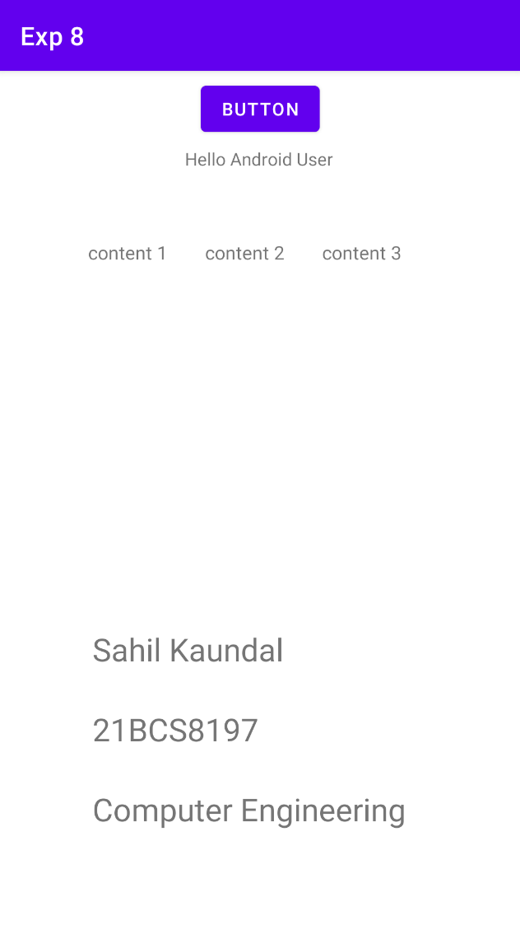 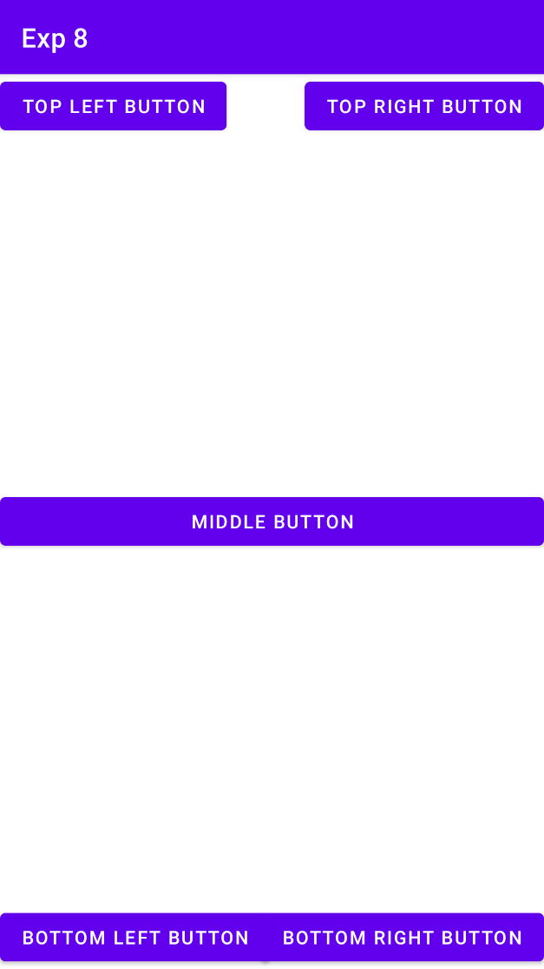

**Learning outcomes (What I have learnt):**

* To design an android application which uses different layouts in android studio.
* Learnt about running application on android studio.